**TRINITY INTERNATIONAL SS & COLLEGE**

**Dillibazar Height, Kathmandu, Nepal**



**LAB WORK # 3: Application Package (MS-Excel)**

**(COMPUTER SCIENCE)**

**SUBMITTED BY: SUBMITTED TO:**

**NAME: Prashim Timsina**

**GRADE: XI (MC1)**

**DATE : [2079/08/09] PRAVEEN KOIRALA**

**Faculty of Computer Science**

**KATHMANDU, NEPAL**

**2022 Table of Contents**

S. No. Page No.

1. Acknowledgement I

2. Objectives II

3. Table of Contents III

4. Theoretical Background (1)

4.1 Application Package

4.1.1 Salary Sheet

4.1.2 COUNTIF Function

4.1.3 Conditional formatting

4.1.4 Sort & Filter

5. Work Done

5.1 Salary Sheet 2

5.2 COUNTIF Function 3

5.3 Conditional Formatting 4

5.4 Sort & Filter 5

6. Conclusion

7. Bibliography

8. Appendix

**2. Objective**

The main objectives of the lab work are as follows:

1. To practice calculating salary sheet using formula, function and conditional statements.
2. To understand and apply COUNTIF function.
3. To understand conditional formatting.
4. To understand sort and filter data in excel

**3. Theoretical Background**

Salary Sheet: Salary Sheet is defined as the sheet used by accountants to keep data and records of all the financial transactions, credit, debit and salary with the employees of the following company.

COUNTIF Function: It is a function that counts the number of cells within a range that meet the given criteria.

Its syntax is,

=COUNTIF(the criteria, the value that you want to count)

Conditional formatting: Conditional Formatting (CF) is a tool that allows you to apply formats to a cell or range of cells, and have that formatting change depending on the value of the cell or the value of a formula. For example, you can have a cell appear bold only when the value of the cell is greater than 100.

Sort: Sorting is the process of arranging data into meaningful order so that you can analyze it more effectively. For example, you might want to order sales data by calendar month so that you can produce a graph of sales performance.

Filter: Data filtering is the process of choosing a smaller part of your data set and using that subset for viewing or analysis. Filtering is generally (but not always) temporary – the complete data set is kept, but only part of it is used for the calculation.

Page: 1

**4. Work Done**

1) Salary Sheet

A salary Sheet was made by using many excel functions such as SUM, PRODUCT, IF, etc.

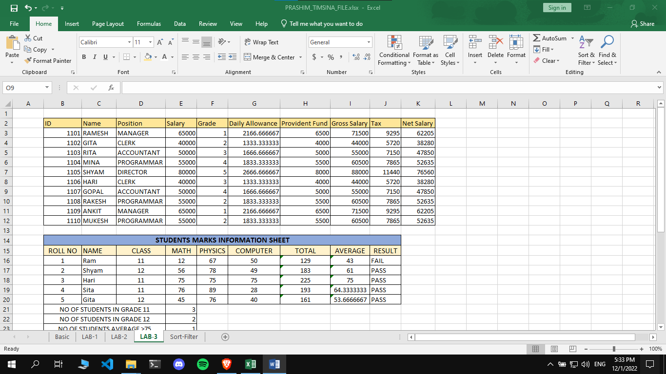

Page: 2

2) COUNTIF Function

COUNTIF Functions can be triggered by using = with COUNTIF parameters

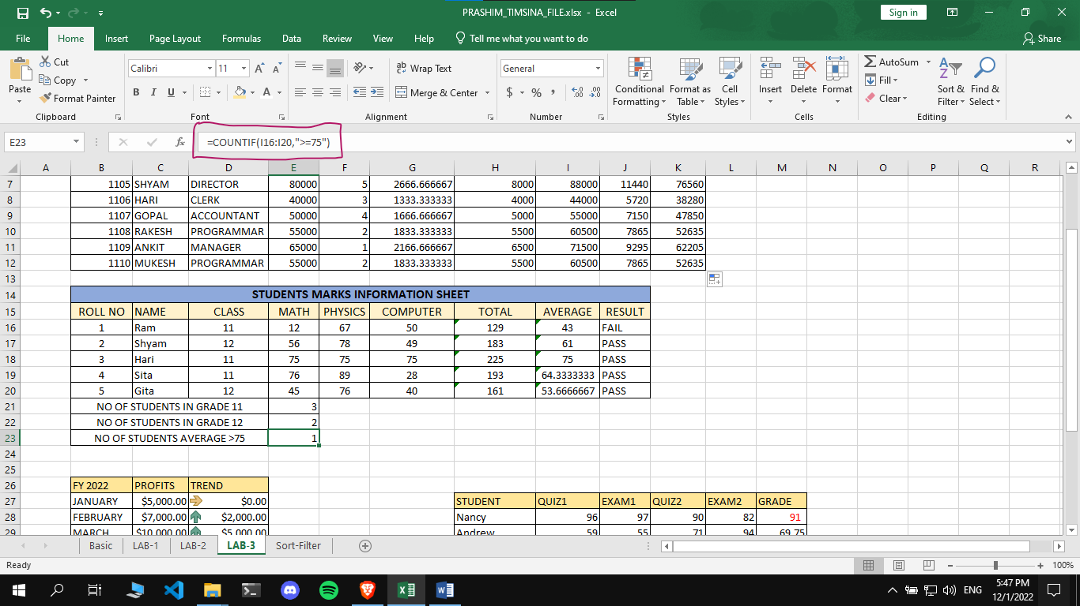

Page: 3

3) Conditional formatting

Some formatting can be triggered in excel using conditional formatting which can be accessed in the center of home tab.

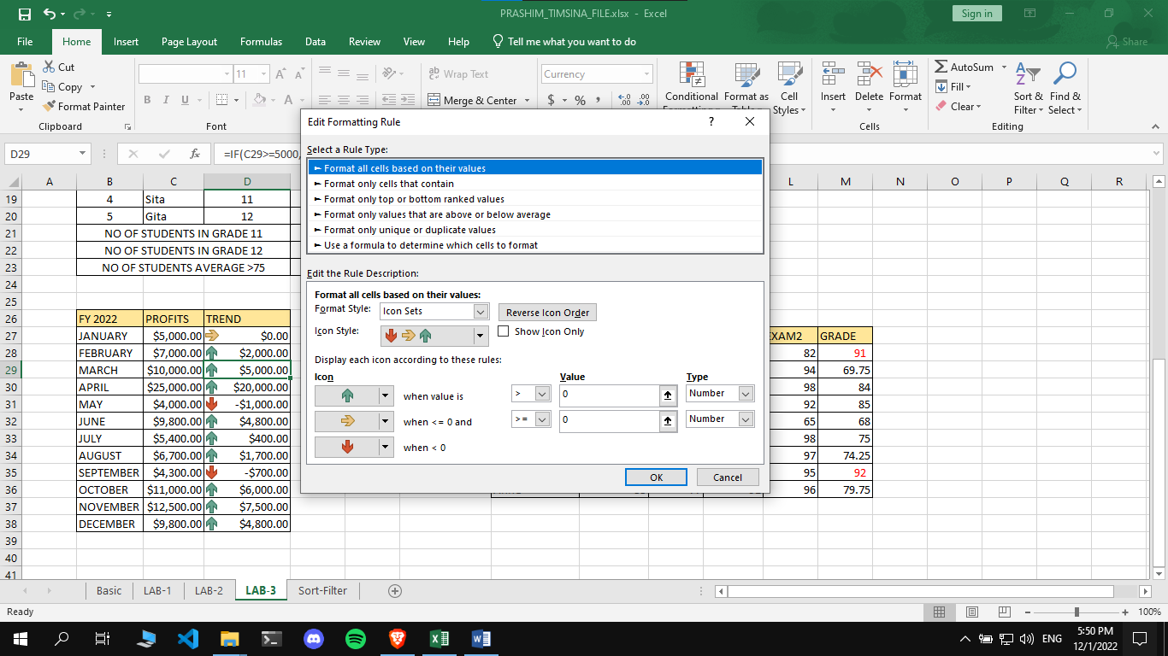

Page: 4

4) Sort and Filter

A certain data set can be filtered and sorted according to our need. It can be done by clicking a cell and navigating to the top left of the home tab, clicking the sort and filter tab.

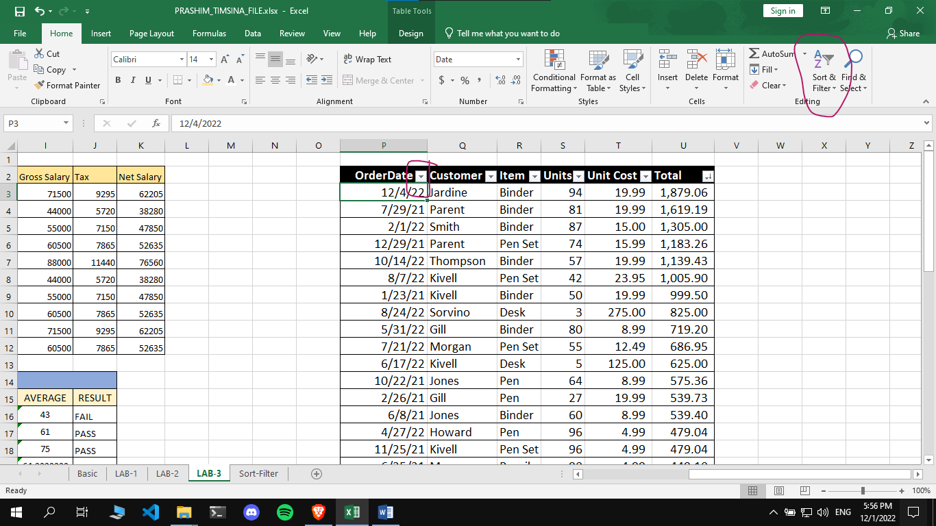

Page: 5